1. **Algorithm**
   1. In the constructor of Graph Class, open file and read in the nodes and lines separately in and store nodes and lines in two dictionaries.
   2. In the findPath method, claim a global variable pathlist to store each found paths. Pass startID, endID, the current path characters, travelled nodes and travelled lines to the inside help function findPathInside.
   3. In the findPathInside function, in order not to change the passed in travellednodes, travelled lines, copy each variable inside the function and use the new copy rather than changing the object the pointer pointing to.
   4. In findShortestPath method, use the fundPath function first to get all the possible path from the startID and endID. Since the findPath returns each possible path’s length, the possible path with shorted length can be picked by comparison of paths’ length.
2. **Test Procedure**
   1. Test if the class works with Graph2. See 3.2 and 4.1, including print the whole graph, find all possible paths and shortest path of each possible (start node, end node) pair;
   2. Do the same test as 2.1 to see if the class works with Graph2. See 3.3 and 4.2;
3. **Code**
   1. Class Code
      1. Vector Class

''

import math

class Vector(object):

def __init__(self, data):

self.v = data

def __getitem__(self, i):

return self.v[i]

def __setitem__(self, i, val):

self.v[i] = val

def __len__(self):

return len(self.v)

def __add__(self, x):

if type(x) == Vector:

w = self.v[:]

for i in range(0,len(self)):

w[i] += x[i]

return w

else:

raise TypeError

def __sub__(self, x):

if type(x) == Vector:

w = self.v[:]

for i in range(0,len(self)):

w[i] -= x[i]

return w

else:

raise TypeError

def __mul__(self, x):

if type(x) == Vector:

w = 0.0

for i in range(0,len(self)):

w += self.v[i] * x[i]

return w

else:

raise TypeError

def __div__(self, x):

raise NotImplemented

def __str__(self):

return str( self.v )

def __repr__(self):

return self.__str__()

def length(self):

sum=0.0

for i in self.v:

sum+=i**2

return math.sqrt(sum)

* + 1. Node Class

from Vector import *

class Node(object):

def __init__(self, id, v):

self.id = id

self.node = Vector(v)

self.lines = []

def getPosition(self):

return self.node

def getID(self):

return self.id

def attach(self, lineID):

self.lines.append(lineID)

def detach(self, lineID):

self.lines.remove(lineID)

def __str__(self):

return(self.id + str(self.node)+str(self.lines))

def getAttachedLines(self):

return self.lines

* + 1. Line Class

from enable.savage.svg.css.values import length

class Line(object):

def __init__(self, id, nodeIid, nodeJid, length):

self.id = id

self.nodes = [nodeIid, nodeJid]

self.nodes.sort()

self.length=length

def __len__(self):

return self.length

def getID(self):

return self.id

def getNodes(self):

return self.nodes

def attach(self, nodeID):

self.nodes.append(nodeID)

def detach(self, nodeID):

self.nodes.remove(nodeID)

def __str__(self):

return (self.id+str(self.nodes))

def length(self):

return self.length

* + 1. Graph Class

import os

from Graph import *

from Line import *

from Node import *

from docutils.parsers.rst.directives import path

from copy import deepcopy

class Graph(object):

def __init__(self, folder_name):

'''

Constructor

'''

os.chdir( folder_name )

self.nodes = dict()

f = open('nodes.txt', 'r')

for line in f:

l=line.rstrip()

l=l.split('\t')

id=l[0]

v=Vector([float(l[1]), float(l[2])])

self.nodes.setdefault(id, Node(id,v))

f.close()

self.lines = dict ()

f = open('lines.txt', 'r')

for line in f:

l=line.rstrip()

l=l.split('\t')

for n in self.nodes.viewkeys():

if n==l[1]:

self.nodes[n].attach(l[0])

p1=self.nodes[n].getPosition()

elif n==l[2]:

self.nodes[n].attach(l[0]);

p2=self.nodes[n].getPosition()

length=(Vector(p1-p2)).length()

self.lines.setdefault(l[0], Line(l[0], l[1], l[2],length))

f.close()

def __str__(self):

nodelist='\n'

linelist='\n'

for i in self.nodes.viewvalues():

nodelist+='NodeId:'+str(i)+'\n'

for j in self.lines.viewvalues():

linelist+='LineId:'+str(j)+'\n'

return nodelist+'\n'+linelist

def findPath(self, startID, endID):

if startID not in self.nodes.keys() :

print "unknown nodeid=%s" % startID

if endID not in self.nodes.keys():

print "unknown nodeid=%s" % endID

global pathlist

(traveledLines, traveledNodes)=([],[])

path= dict (nodepath=[], linepath=[], length= 0.0)

pathlist=[]

startID=str(startID)

endID=str(endID)

self.findPathInside(startID,endID, path,traveledNodes, traveledLines)

return pathlist

def findPathInside(self, startID, endID, path,traveledNodes, traveledLines):

if startID not in traveledNodes:

traveledNodes=deepcopy(traveledNodes)

traveledNodes.append(startID)

traveledLines=deepcopy(traveledLines)

for l in self.nodes[startID].getAttachedLines():

if (l not in traveledLines):

traveledLines.append(l)

for n in self.lines[l].getNodes():

if n not in traveledNodes:

pathInside=deepcopy(path)

pathInside['nodepath'].append(startID)

pathInside['linepath'].append(l)

pathInside['length']+=self.lines[l].length

if n==endID:

pathInside['nodepath'].append(endID)

pathlist.append(pathInside)

else:

self.findPathInside(n, endID, pathInside,traveledNodes, traveledLines)

def findShortestPath(self, startID, endID):

allPath=self.findPath(startID, endID)

shortestLen=allPath[0]['length']

j=0

for i in range(1,len(allPath)):

if allPath[i]['length']<shortestLen:

j=i

shortestLen=allPath[i]['length']

return allPath[j]

def numNodes(self):

return len(self.nodes)

def numLines(self):

return len(self.lines)

* 1. Test Code-1

from Graph import *

g = Graph('Example_Input\Graph1')

print g

for nodeIDi in g.nodes.keys():

for nodeIDj in g.nodes.keys():

if nodeIDi!=nodeIDj:

pathlist=g.findPath(nodeIDi, nodeIDj)

for path in pathlist:

print "The path from %s to %s goes through %s, travel lines %s and has a length of %s" \

% ( nodeIDi, nodeIDj, path['nodepath'], path['linepath'],path['length'] )

shortpath=g.findShortestPath( nodeIDi, nodeIDj)

print "The shortest path from %s to %s goes through %s, travel lines %s and has a length of %s \n" \

% ( nodeIDi, nodeIDj, shortpath['nodepath'], shortpath['linepath'], shortpath['length'] )

* 1. Test Code-2

g = Graph('Example_Input\Graph2')

print g

for nodeIDi in g.nodes.keys():

for nodeIDj in g.nodes.keys():

if nodeIDi!=nodeIDj:

pathlist=g.findPath(nodeIDi, nodeIDj)

for path in pathlist:

print "The path from %s to %s goes through %s, travel lines %s and has a length of %s" \

% ( nodeIDi, nodeIDj, path['nodepath'], path['linepath'],path['length'] )

shortpath=g.findShortestPath( nodeIDi, nodeIDj)

print "The shortest path from %s to %s goes through %s, travel lines %s and has a length of %s \n" \

% ( nodeIDi, nodeIDj, shortpath['nodepath'], shortpath['linepath'], shortpath['length'] )

1. **Demonstration**

Comparison between the outcome result in 4.1,4.1 and the paper work (several examples are chosen), demonstrates the successful implementation.

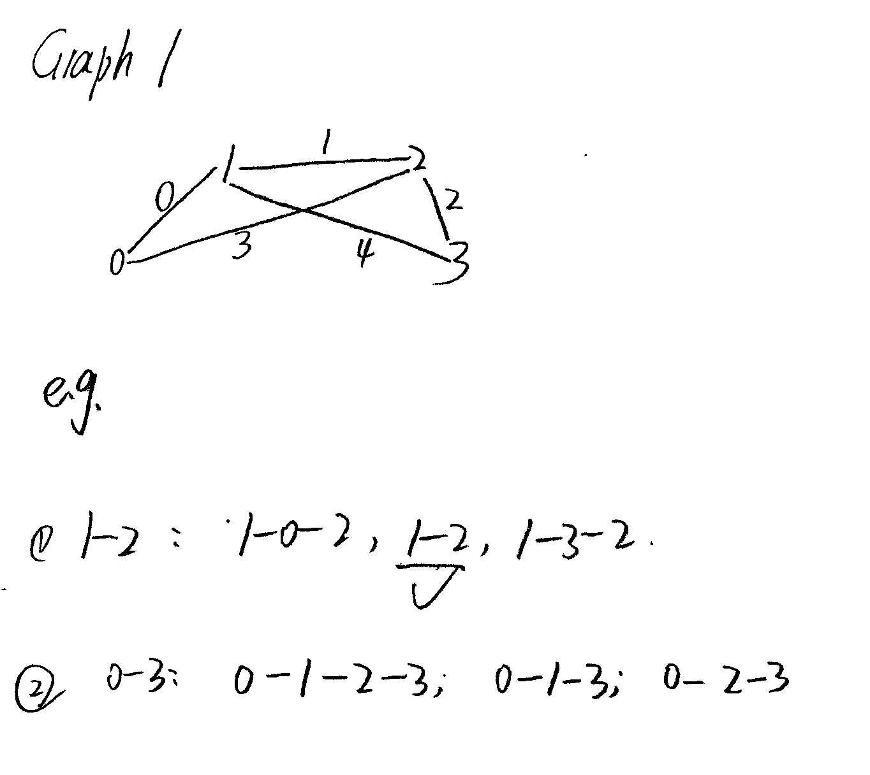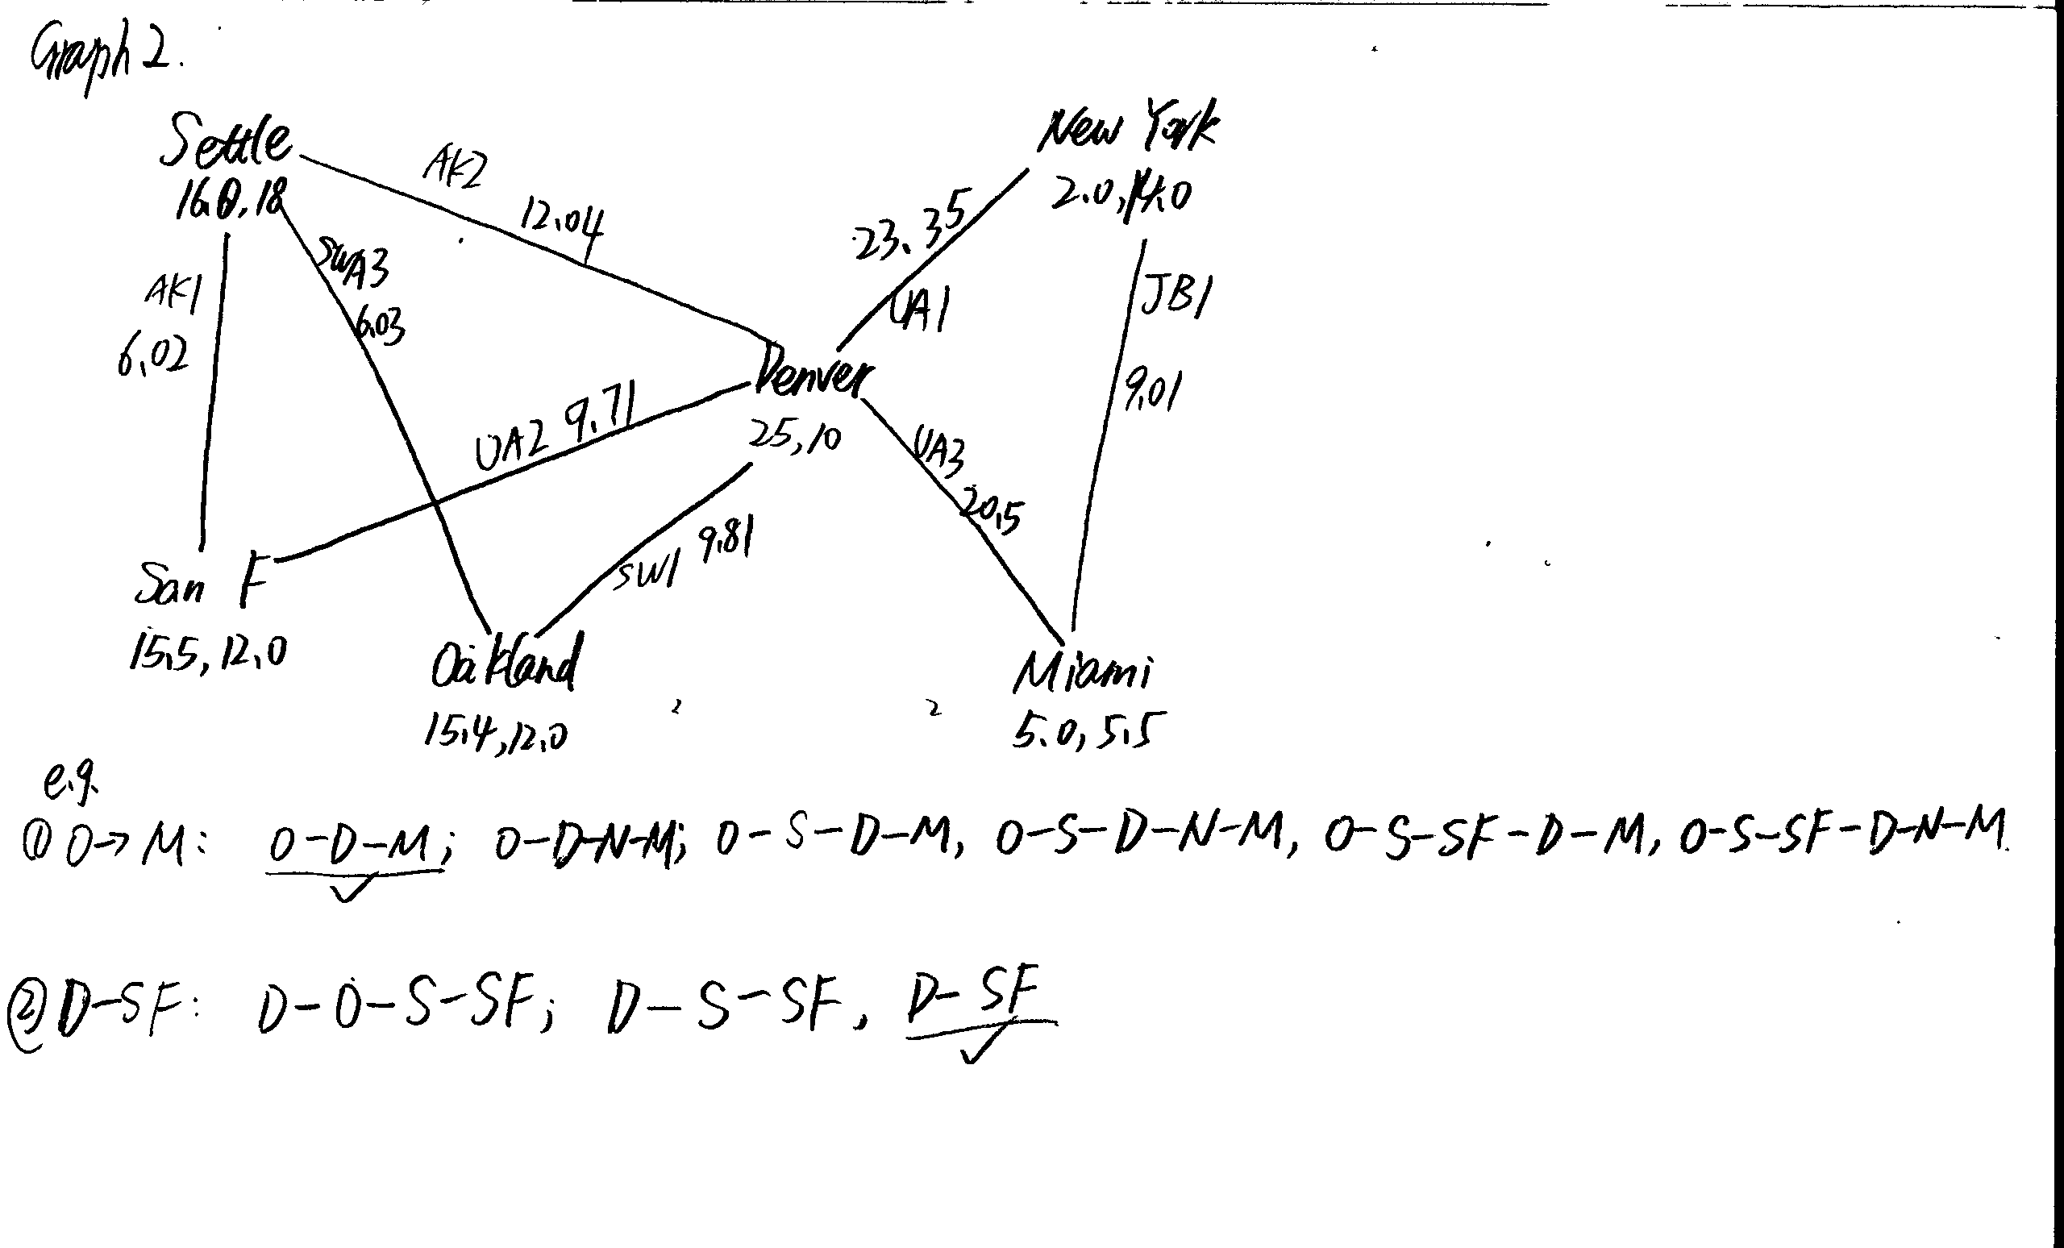

1. **Test outcome**
   1. Test outcome for Test Code-1

NodeId:1[15.5, 5.0]['0', '1', '4']

NodeId:0[10.0, 0.0]['0', '3']

NodeId:3[45.0, 0.0]['2', '4']

NodeId:2[23.0, 5.0]['1', '2', '3']

LineId:1['1', '2']

LineId:0['0', '1']

LineId:3['0', '2']

LineId:2['2', '3']

LineId:4['1', '3']

The path from 1 to 0 goes through ['1', '0'], travel lines ['0'] and has a length of 7.43303437366

The path from 1 to 0 goes through ['1', '2', '0'], travel lines ['1', '3'] and has a length of 21.4283882772

The path from 1 to 0 goes through ['1', '3', '2', '0'], travel lines ['4', '2', '3'] and has a length of 66.4101452233

The shortest path from 1 to 0 goes through ['1', '0'], travel lines ['0'] and has a length of 7.43303437366

The path from 1 to 3 goes through ['1', '0', '2', '3'], travel lines ['0', '3', '2'] and has a length of 43.9224509962

The path from 1 to 3 goes through ['1', '2', '3'], travel lines ['1', '2'] and has a length of 30.0610283454

The path from 1 to 3 goes through ['1', '3'], travel lines ['4'] and has a length of 29.9207286008

The shortest path from 1 to 3 goes through ['1', '3'], travel lines ['4'] and has a length of 29.9207286008

The path from 1 to 2 goes through ['1', '0', '2'], travel lines ['0', '3'] and has a length of 21.3614226508

The path from 1 to 2 goes through ['1', '2'], travel lines ['1'] and has a length of 7.5

The path from 1 to 2 goes through ['1', '3', '2'], travel lines ['4', '2'] and has a length of 52.4817569461

The shortest path from 1 to 2 goes through ['1', '2'], travel lines ['1'] and has a length of 7.5

The path from 0 to 1 goes through ['0', '1'], travel lines ['0'] and has a length of 7.43303437366

The path from 0 to 1 goes through ['0', '2', '1'], travel lines ['3', '1'] and has a length of 21.4283882772

The path from 0 to 1 goes through ['0', '2', '3', '1'], travel lines ['3', '2', '4'] and has a length of 66.4101452233

The shortest path from 0 to 1 goes through ['0', '1'], travel lines ['0'] and has a length of 7.43303437366

The path from 0 to 3 goes through ['0', '1', '2', '3'], travel lines ['0', '1', '2'] and has a length of 37.494062719

The path from 0 to 3 goes through ['0', '1', '3'], travel lines ['0', '4'] and has a length of 37.3537629744

The path from 0 to 3 goes through ['0', '2', '1', '3'], travel lines ['3', '1', '4'] and has a length of 51.3491168779

The path from 0 to 3 goes through ['0', '2', '3'], travel lines ['3', '2'] and has a length of 36.4894166225

The shortest path from 0 to 3 goes through ['0', '2', '3'], travel lines ['3', '2'] and has a length of 36.4894166225

The path from 0 to 2 goes through ['0', '1', '2'], travel lines ['0', '1'] and has a length of 14.9330343737

The path from 0 to 2 goes through ['0', '1', '3', '2'], travel lines ['0', '4', '2'] and has a length of 59.9147913198

The path from 0 to 2 goes through ['0', '2'], travel lines ['3'] and has a length of 13.9283882772

The shortest path from 0 to 2 goes through ['0', '2'], travel lines ['3'] and has a length of 13.9283882772

The path from 3 to 1 goes through ['3', '2', '1'], travel lines ['2', '1'] and has a length of 30.0610283454

The path from 3 to 1 goes through ['3', '2', '0', '1'], travel lines ['2', '3', '0'] and has a length of 43.9224509962

The path from 3 to 1 goes through ['3', '1'], travel lines ['4'] and has a length of 29.9207286008

The shortest path from 3 to 1 goes through ['3', '1'], travel lines ['4'] and has a length of 29.9207286008

The path from 3 to 0 goes through ['3', '2', '1', '0'], travel lines ['2', '1', '0'] and has a length of 37.494062719

The path from 3 to 0 goes through ['3', '2', '0'], travel lines ['2', '3'] and has a length of 36.4894166225

The path from 3 to 0 goes through ['3', '1', '0'], travel lines ['4', '0'] and has a length of 37.3537629744

The path from 3 to 0 goes through ['3', '1', '2', '0'], travel lines ['4', '1', '3'] and has a length of 51.3491168779

The shortest path from 3 to 0 goes through ['3', '2', '0'], travel lines ['2', '3'] and has a length of 36.4894166225

The path from 3 to 2 goes through ['3', '2'], travel lines ['2'] and has a length of 22.5610283454

The path from 3 to 2 goes through ['3', '1', '0', '2'], travel lines ['4', '0', '3'] and has a length of 51.2821512516

The path from 3 to 2 goes through ['3', '1', '2'], travel lines ['4', '1'] and has a length of 37.4207286008

The shortest path from 3 to 2 goes through ['3', '2'], travel lines ['2'] and has a length of 22.5610283454

The path from 2 to 1 goes through ['2', '1'], travel lines ['1'] and has a length of 7.5

The path from 2 to 1 goes through ['2', '3', '1'], travel lines ['2', '4'] and has a length of 52.4817569461

The path from 2 to 1 goes through ['2', '0', '1'], travel lines ['3', '0'] and has a length of 21.3614226508

The shortest path from 2 to 1 goes through ['2', '1'], travel lines ['1'] and has a length of 7.5

The path from 2 to 0 goes through ['2', '1', '0'], travel lines ['1', '0'] and has a length of 14.9330343737

The path from 2 to 0 goes through ['2', '3', '1', '0'], travel lines ['2', '4', '0'] and has a length of 59.9147913198

The path from 2 to 0 goes through ['2', '0'], travel lines ['3'] and has a length of 13.9283882772

The shortest path from 2 to 0 goes through ['2', '0'], travel lines ['3'] and has a length of 13.9283882772

The path from 2 to 3 goes through ['2', '1', '3'], travel lines ['1', '4'] and has a length of 37.4207286008

The path from 2 to 3 goes through ['2', '3'], travel lines ['2'] and has a length of 22.5610283454

The path from 2 to 3 goes through ['2', '0', '1', '3'], travel lines ['3', '0', '4'] and has a length of 51.2821512516

The shortest path from 2 to 3 goes through ['2', '3'], travel lines ['2'] and has a length of 22.5610283454

* 1. Test outcome for Test Code-2

NodeId:Oakland[15.4, 12.0]['SWA1', 'SWA3']

NodeId:Miami[5.0, 5.5]['UA3', 'JB1']

NodeId:Denver[25.0, 10.0]['AK2', 'SWA1', 'UA1', 'UA2', 'UA3']

NodeId:New York[2.0, 14.0]['UA1', 'JB1']

NodeId:San Francisco[15.5, 12.0]['AK1', 'UA2']

NodeId:Seattle[16.0, 18.0]['AK1', 'AK2', 'SWA3']

LineId:JB1['Miami', 'New York']

LineId:UA1['Denver', 'New York']

LineId:AK2['Denver', 'Seattle']

LineId:AK1['San Francisco', 'Seattle']

LineId:UA2['Denver', 'San Francisco']

LineId:SWA1['Denver', 'Oakland']

LineId:SWA3['Oakland', 'Seattle']

LineId:UA3['Denver', 'Miami']

The path from Oakland to Miami goes through ['Oakland', 'Denver', 'New York', 'Miami'], travel lines ['SWA1', 'UA1', 'JB1'] and has a length of 42.1652337862

The path from Oakland to Miami goes through ['Oakland', 'Denver', 'Miami'], travel lines ['SWA1', 'UA3'] and has a length of 30.3061205377

The path from Oakland to Miami goes through ['Oakland', 'Seattle', 'San Francisco', 'Denver', 'New York', 'Miami'], travel lines ['SWA3', 'AK1', 'UA2', 'UA1', 'JB1'] and has a length of 54.1180798301

The path from Oakland to Miami goes through ['Oakland', 'Seattle', 'San Francisco', 'Denver', 'Miami'], travel lines ['SWA3', 'AK1', 'UA2', 'UA3'] and has a length of 42.2589665815

The path from Oakland to Miami goes through ['Oakland', 'Seattle', 'Denver', 'New York', 'Miami'], travel lines ['SWA3', 'AK2', 'UA1', 'JB1'] and has a length of 50.4306332

The path from Oakland to Miami goes through ['Oakland', 'Seattle', 'Denver', 'Miami'], travel lines ['SWA3', 'AK2', 'UA3'] and has a length of 38.5715199515

The shortest path from Oakland to Miami goes through ['Oakland', 'Denver', 'Miami'], travel lines ['SWA1', 'UA3'] and has a length of 30.3061205377

The path from Oakland to Denver goes through ['Oakland', 'Denver'], travel lines ['SWA1'] and has a length of 9.80612053771

The path from Oakland to Denver goes through ['Oakland', 'Seattle', 'San Francisco', 'Denver'], travel lines ['SWA3', 'AK1', 'UA2'] and has a length of 21.7589665815

The path from Oakland to Denver goes through ['Oakland', 'Seattle', 'Denver'], travel lines ['SWA3', 'AK2'] and has a length of 18.0715199515

The shortest path from Oakland to Denver goes through ['Oakland', 'Denver'], travel lines ['SWA1'] and has a length of 9.80612053771

The path from Oakland to New York goes through ['Oakland', 'Denver', 'New York'], travel lines ['SWA1', 'UA1'] and has a length of 33.1513555976

The path from Oakland to New York goes through ['Oakland', 'Denver', 'Miami', 'New York'], travel lines ['SWA1', 'UA3', 'JB1'] and has a length of 39.3199987264

The path from Oakland to New York goes through ['Oakland', 'Seattle', 'San Francisco', 'Denver', 'New York'], travel lines ['SWA3', 'AK1', 'UA2', 'UA1'] and has a length of 45.1042016414

The path from Oakland to New York goes through ['Oakland', 'Seattle', 'San Francisco', 'Denver', 'Miami', 'New York'], travel lines ['SWA3', 'AK1', 'UA2', 'UA3', 'JB1'] and has a length of 51.2728447702

The path from Oakland to New York goes through ['Oakland', 'Seattle', 'Denver', 'New York'], travel lines ['SWA3', 'AK2', 'UA1'] and has a length of 41.4167550113

The path from Oakland to New York goes through ['Oakland', 'Seattle', 'Denver', 'Miami', 'New York'], travel lines ['SWA3', 'AK2', 'UA3', 'JB1'] and has a length of 47.5853981401

The shortest path from Oakland to New York goes through ['Oakland', 'Denver', 'New York'], travel lines ['SWA1', 'UA1'] and has a length of 33.1513555976

The path from Oakland to San Francisco goes through ['Oakland', 'Denver', 'Seattle', 'San Francisco'], travel lines ['SWA1', 'AK2', 'AK1'] and has a length of 27.8685124059

The path from Oakland to San Francisco goes through ['Oakland', 'Denver', 'San Francisco'], travel lines ['SWA1', 'UA2'] and has a length of 19.5143644572

The path from Oakland to San Francisco goes through ['Oakland', 'Seattle', 'San Francisco'], travel lines ['SWA3', 'AK1'] and has a length of 12.0507226621

The path from Oakland to San Francisco goes through ['Oakland', 'Seattle', 'Denver', 'San Francisco'], travel lines ['SWA3', 'AK2', 'UA2'] and has a length of 27.7797638709

The shortest path from Oakland to San Francisco goes through ['Oakland', 'Seattle', 'San Francisco'], travel lines ['SWA3', 'AK1'] and has a length of 12.0507226621

The path from Oakland to Seattle goes through ['Oakland', 'Denver', 'Seattle'], travel lines ['SWA1', 'AK2'] and has a length of 21.8477151165

The path from Oakland to Seattle goes through ['Oakland', 'Denver', 'San Francisco', 'Seattle'], travel lines ['SWA1', 'UA2', 'AK1'] and has a length of 25.5351617466

The path from Oakland to Seattle goes through ['Oakland', 'Seattle'], travel lines ['SWA3'] and has a length of 6.02992537267

The shortest path from Oakland to Seattle goes through ['Oakland', 'Seattle'], travel lines ['SWA3'] and has a length of 6.02992537267

The path from Miami to Oakland goes through ['Miami', 'Denver', 'Seattle', 'Oakland'], travel lines ['UA3', 'AK2', 'SWA3'] and has a length of 38.5715199515

The path from Miami to Oakland goes through ['Miami', 'Denver', 'Oakland'], travel lines ['UA3', 'SWA1'] and has a length of 30.3061205377

The path from Miami to Oakland goes through ['Miami', 'Denver', 'San Francisco', 'Seattle', 'Oakland'], travel lines ['UA3', 'UA2', 'AK1', 'SWA3'] and has a length of 42.2589665815

The path from Miami to Oakland goes through ['Miami', 'New York', 'Denver', 'Seattle', 'Oakland'], travel lines ['JB1', 'UA1', 'AK2', 'SWA3'] and has a length of 50.4306332

The path from Miami to Oakland goes through ['Miami', 'New York', 'Denver', 'Oakland'], travel lines ['JB1', 'UA1', 'SWA1'] and has a length of 42.1652337862

The path from Miami to Oakland goes through ['Miami', 'New York', 'Denver', 'San Francisco', 'Seattle', 'Oakland'], travel lines ['JB1', 'UA1', 'UA2', 'AK1', 'SWA3'] and has a length of 54.1180798301

The shortest path from Miami to Oakland goes through ['Miami', 'Denver', 'Oakland'], travel lines ['UA3', 'SWA1'] and has a length of 30.3061205377

The path from Miami to Denver goes through ['Miami', 'Denver'], travel lines ['UA3'] and has a length of 20.5

The path from Miami to Denver goes through ['Miami', 'New York', 'Denver'], travel lines ['JB1', 'UA1'] and has a length of 32.3591132485

The shortest path from Miami to Denver goes through ['Miami', 'Denver'], travel lines ['UA3'] and has a length of 20.5

The path from Miami to New York goes through ['Miami', 'Denver', 'New York'], travel lines ['UA3', 'UA1'] and has a length of 43.8452350599

The path from Miami to New York goes through ['Miami', 'New York'], travel lines ['JB1'] and has a length of 9.01387818866

The shortest path from Miami to New York goes through ['Miami', 'New York'], travel lines ['JB1'] and has a length of 9.01387818866

The path from Miami to San Francisco goes through ['Miami', 'Denver', 'Seattle', 'San Francisco'], travel lines ['UA3', 'AK2', 'AK1'] and has a length of 38.5623918682

The path from Miami to San Francisco goes through ['Miami', 'Denver', 'Oakland', 'Seattle', 'San Francisco'], travel lines ['UA3', 'SWA1', 'SWA3', 'AK1'] and has a length of 42.3568431998

The path from Miami to San Francisco goes through ['Miami', 'Denver', 'San Francisco'], travel lines ['UA3', 'UA2'] and has a length of 30.2082439195

The path from Miami to San Francisco goes through ['Miami', 'New York', 'Denver', 'Seattle', 'San Francisco'], travel lines ['JB1', 'UA1', 'AK2', 'AK1'] and has a length of 50.4215051167

The path from Miami to San Francisco goes through ['Miami', 'New York', 'Denver', 'Oakland', 'Seattle', 'San Francisco'], travel lines ['JB1', 'UA1', 'SWA1', 'SWA3', 'AK1'] and has a length of 54.2159564483

The path from Miami to San Francisco goes through ['Miami', 'New York', 'Denver', 'San Francisco'], travel lines ['JB1', 'UA1', 'UA2'] and has a length of 42.067357168

The shortest path from Miami to San Francisco goes through ['Miami', 'Denver', 'San Francisco'], travel lines ['UA3', 'UA2'] and has a length of 30.2082439195

The path from Miami to Seattle goes through ['Miami', 'Denver', 'Seattle'], travel lines ['UA3', 'AK2'] and has a length of 32.5415945788

The path from Miami to Seattle goes through ['Miami', 'Denver', 'Oakland', 'Seattle'], travel lines ['UA3', 'SWA1', 'SWA3'] and has a length of 36.3360459104

The path from Miami to Seattle goes through ['Miami', 'Denver', 'San Francisco', 'Seattle'], travel lines ['UA3', 'UA2', 'AK1'] and has a length of 36.2290412089

The path from Miami to Seattle goes through ['Miami', 'New York', 'Denver', 'Seattle'], travel lines ['JB1', 'UA1', 'AK2'] and has a length of 44.4007078273

The path from Miami to Seattle goes through ['Miami', 'New York', 'Denver', 'Oakland', 'Seattle'], travel lines ['JB1', 'UA1', 'SWA1', 'SWA3'] and has a length of 48.1951591589

The path from Miami to Seattle goes through ['Miami', 'New York', 'Denver', 'San Francisco', 'Seattle'], travel lines ['JB1', 'UA1', 'UA2', 'AK1'] and has a length of 48.0881544574

The shortest path from Miami to Seattle goes through ['Miami', 'Denver', 'Seattle'], travel lines ['UA3', 'AK2'] and has a length of 32.5415945788

The path from Denver to Oakland goes through ['Denver', 'Seattle', 'Oakland'], travel lines ['AK2', 'SWA3'] and has a length of 18.0715199515

The path from Denver to Oakland goes through ['Denver', 'Oakland'], travel lines ['SWA1'] and has a length of 9.80612053771

The path from Denver to Oakland goes through ['Denver', 'San Francisco', 'Seattle', 'Oakland'], travel lines ['UA2', 'AK1', 'SWA3'] and has a length of 21.7589665815

The shortest path from Denver to Oakland goes through ['Denver', 'Oakland'], travel lines ['SWA1'] and has a length of 9.80612053771

The path from Denver to Miami goes through ['Denver', 'New York', 'Miami'], travel lines ['UA1', 'JB1'] and has a length of 32.3591132485

The path from Denver to Miami goes through ['Denver', 'Miami'], travel lines ['UA3'] and has a length of 20.5

The shortest path from Denver to Miami goes through ['Denver', 'Miami'], travel lines ['UA3'] and has a length of 20.5

The path from Denver to New York goes through ['Denver', 'New York'], travel lines ['UA1'] and has a length of 23.3452350599

The path from Denver to New York goes through ['Denver', 'Miami', 'New York'], travel lines ['UA3', 'JB1'] and has a length of 29.5138781887

The shortest path from Denver to New York goes through ['Denver', 'New York'], travel lines ['UA1'] and has a length of 23.3452350599

The path from Denver to San Francisco goes through ['Denver', 'Seattle', 'San Francisco'], travel lines ['AK2', 'AK1'] and has a length of 18.0623918682

The path from Denver to San Francisco goes through ['Denver', 'Oakland', 'Seattle', 'San Francisco'], travel lines ['SWA1', 'SWA3', 'AK1'] and has a length of 21.8568431998

The path from Denver to San Francisco goes through ['Denver', 'San Francisco'], travel lines ['UA2'] and has a length of 9.70824391947

The shortest path from Denver to San Francisco goes through ['Denver', 'San Francisco'], travel lines ['UA2'] and has a length of 9.70824391947

The path from Denver to Seattle goes through ['Denver', 'Seattle'], travel lines ['AK2'] and has a length of 12.0415945788

The path from Denver to Seattle goes through ['Denver', 'Oakland', 'Seattle'], travel lines ['SWA1', 'SWA3'] and has a length of 15.8360459104

The path from Denver to Seattle goes through ['Denver', 'San Francisco', 'Seattle'], travel lines ['UA2', 'AK1'] and has a length of 15.7290412089

The shortest path from Denver to Seattle goes through ['Denver', 'Seattle'], travel lines ['AK2'] and has a length of 12.0415945788

The path from New York to Oakland goes through ['New York', 'Denver', 'Seattle', 'Oakland'], travel lines ['UA1', 'AK2', 'SWA3'] and has a length of 41.4167550113

The path from New York to Oakland goes through ['New York', 'Denver', 'Oakland'], travel lines ['UA1', 'SWA1'] and has a length of 33.1513555976

The path from New York to Oakland goes through ['New York', 'Denver', 'San Francisco', 'Seattle', 'Oakland'], travel lines ['UA1', 'UA2', 'AK1', 'SWA3'] and has a length of 45.1042016414

The path from New York to Oakland goes through ['New York', 'Miami', 'Denver', 'Seattle', 'Oakland'], travel lines ['JB1', 'UA3', 'AK2', 'SWA3'] and has a length of 47.5853981401

The path from New York to Oakland goes through ['New York', 'Miami', 'Denver', 'Oakland'], travel lines ['JB1', 'UA3', 'SWA1'] and has a length of 39.3199987264

The path from New York to Oakland goes through ['New York', 'Miami', 'Denver', 'San Francisco', 'Seattle', 'Oakland'], travel lines ['JB1', 'UA3', 'UA2', 'AK1', 'SWA3'] and has a length of 51.2728447702

The shortest path from New York to Oakland goes through ['New York', 'Denver', 'Oakland'], travel lines ['UA1', 'SWA1'] and has a length of 33.1513555976

The path from New York to Miami goes through ['New York', 'Denver', 'Miami'], travel lines ['UA1', 'UA3'] and has a length of 43.8452350599

The path from New York to Miami goes through ['New York', 'Miami'], travel lines ['JB1'] and has a length of 9.01387818866

The shortest path from New York to Miami goes through ['New York', 'Miami'], travel lines ['JB1'] and has a length of 9.01387818866

The path from New York to Denver goes through ['New York', 'Denver'], travel lines ['UA1'] and has a length of 23.3452350599

The path from New York to Denver goes through ['New York', 'Miami', 'Denver'], travel lines ['JB1', 'UA3'] and has a length of 29.5138781887

The shortest path from New York to Denver goes through ['New York', 'Denver'], travel lines ['UA1'] and has a length of 23.3452350599

The path from New York to San Francisco goes through ['New York', 'Denver', 'Seattle', 'San Francisco'], travel lines ['UA1', 'AK2', 'AK1'] and has a length of 41.407626928

The path from New York to San Francisco goes through ['New York', 'Denver', 'Oakland', 'Seattle', 'San Francisco'], travel lines ['UA1', 'SWA1', 'SWA3', 'AK1'] and has a length of 45.2020782596

The path from New York to San Francisco goes through ['New York', 'Denver', 'San Francisco'], travel lines ['UA1', 'UA2'] and has a length of 33.0534789793

The path from New York to San Francisco goes through ['New York', 'Miami', 'Denver', 'Seattle', 'San Francisco'], travel lines ['JB1', 'UA3', 'AK2', 'AK1'] and has a length of 47.5762700568

The path from New York to San Francisco goes through ['New York', 'Miami', 'Denver', 'Oakland', 'Seattle', 'San Francisco'], travel lines ['JB1', 'UA3', 'SWA1', 'SWA3', 'AK1'] and has a length of 51.3707213884

The path from New York to San Francisco goes through ['New York', 'Miami', 'Denver', 'San Francisco'], travel lines ['JB1', 'UA3', 'UA2'] and has a length of 39.2221221081

The shortest path from New York to San Francisco goes through ['New York', 'Denver', 'San Francisco'], travel lines ['UA1', 'UA2'] and has a length of 33.0534789793

The path from New York to Seattle goes through ['New York', 'Denver', 'Seattle'], travel lines ['UA1', 'AK2'] and has a length of 35.3868296386

The path from New York to Seattle goes through ['New York', 'Denver', 'Oakland', 'Seattle'], travel lines ['UA1', 'SWA1', 'SWA3'] and has a length of 39.1812809702

The path from New York to Seattle goes through ['New York', 'Denver', 'San Francisco', 'Seattle'], travel lines ['UA1', 'UA2', 'AK1'] and has a length of 39.0742762687

The path from New York to Seattle goes through ['New York', 'Miami', 'Denver', 'Seattle'], travel lines ['JB1', 'UA3', 'AK2'] and has a length of 41.5554727675

The path from New York to Seattle goes through ['New York', 'Miami', 'Denver', 'Oakland', 'Seattle'], travel lines ['JB1', 'UA3', 'SWA1', 'SWA3'] and has a length of 45.349924099

The path from New York to Seattle goes through ['New York', 'Miami', 'Denver', 'San Francisco', 'Seattle'], travel lines ['JB1', 'UA3', 'UA2', 'AK1'] and has a length of 45.2429193975

The shortest path from New York to Seattle goes through ['New York', 'Denver', 'Seattle'], travel lines ['UA1', 'AK2'] and has a length of 35.3868296386

The path from San Francisco to Oakland goes through ['San Francisco', 'Seattle', 'Denver', 'Oakland'], travel lines ['AK1', 'AK2', 'SWA1'] and has a length of 27.8685124059

The path from San Francisco to Oakland goes through ['San Francisco', 'Seattle', 'Oakland'], travel lines ['AK1', 'SWA3'] and has a length of 12.0507226621

The path from San Francisco to Oakland goes through ['San Francisco', 'Denver', 'Seattle', 'Oakland'], travel lines ['UA2', 'AK2', 'SWA3'] and has a length of 27.7797638709

The path from San Francisco to Oakland goes through ['San Francisco', 'Denver', 'Oakland'], travel lines ['UA2', 'SWA1'] and has a length of 19.5143644572

The shortest path from San Francisco to Oakland goes through ['San Francisco', 'Seattle', 'Oakland'], travel lines ['AK1', 'SWA3'] and has a length of 12.0507226621

The path from San Francisco to Miami goes through ['San Francisco', 'Seattle', 'Denver', 'New York', 'Miami'], travel lines ['AK1', 'AK2', 'UA1', 'JB1'] and has a length of 50.4215051167

The path from San Francisco to Miami goes through ['San Francisco', 'Seattle', 'Denver', 'Miami'], travel lines ['AK1', 'AK2', 'UA3'] and has a length of 38.5623918682

The path from San Francisco to Miami goes through ['San Francisco', 'Seattle', 'Oakland', 'Denver', 'New York', 'Miami'], travel lines ['AK1', 'SWA3', 'SWA1', 'UA1', 'JB1'] and has a length of 54.2159564483

The path from San Francisco to Miami goes through ['San Francisco', 'Seattle', 'Oakland', 'Denver', 'Miami'], travel lines ['AK1', 'SWA3', 'SWA1', 'UA3'] and has a length of 42.3568431998

The path from San Francisco to Miami goes through ['San Francisco', 'Denver', 'New York', 'Miami'], travel lines ['UA2', 'UA1', 'JB1'] and has a length of 42.067357168

The path from San Francisco to Miami goes through ['San Francisco', 'Denver', 'Miami'], travel lines ['UA2', 'UA3'] and has a length of 30.2082439195

The shortest path from San Francisco to Miami goes through ['San Francisco', 'Denver', 'Miami'], travel lines ['UA2', 'UA3'] and has a length of 30.2082439195

The path from San Francisco to Denver goes through ['San Francisco', 'Seattle', 'Denver'], travel lines ['AK1', 'AK2'] and has a length of 18.0623918682

The path from San Francisco to Denver goes through ['San Francisco', 'Seattle', 'Oakland', 'Denver'], travel lines ['AK1', 'SWA3', 'SWA1'] and has a length of 21.8568431998

The path from San Francisco to Denver goes through ['San Francisco', 'Denver'], travel lines ['UA2'] and has a length of 9.70824391947

The shortest path from San Francisco to Denver goes through ['San Francisco', 'Denver'], travel lines ['UA2'] and has a length of 9.70824391947

The path from San Francisco to New York goes through ['San Francisco', 'Seattle', 'Denver', 'New York'], travel lines ['AK1', 'AK2', 'UA1'] and has a length of 41.407626928

The path from San Francisco to New York goes through ['San Francisco', 'Seattle', 'Denver', 'Miami', 'New York'], travel lines ['AK1', 'AK2', 'UA3', 'JB1'] and has a length of 47.5762700568

The path from San Francisco to New York goes through ['San Francisco', 'Seattle', 'Oakland', 'Denver', 'New York'], travel lines ['AK1', 'SWA3', 'SWA1', 'UA1'] and has a length of 45.2020782596

The path from San Francisco to New York goes through ['San Francisco', 'Seattle', 'Oakland', 'Denver', 'Miami', 'New York'], travel lines ['AK1', 'SWA3', 'SWA1', 'UA3', 'JB1'] and has a length of 51.3707213884

The path from San Francisco to New York goes through ['San Francisco', 'Denver', 'New York'], travel lines ['UA2', 'UA1'] and has a length of 33.0534789793

The path from San Francisco to New York goes through ['San Francisco', 'Denver', 'Miami', 'New York'], travel lines ['UA2', 'UA3', 'JB1'] and has a length of 39.2221221081

The shortest path from San Francisco to New York goes through ['San Francisco', 'Denver', 'New York'], travel lines ['UA2', 'UA1'] and has a length of 33.0534789793

The path from San Francisco to Seattle goes through ['San Francisco', 'Seattle'], travel lines ['AK1'] and has a length of 6.0207972894

The path from San Francisco to Seattle goes through ['San Francisco', 'Denver', 'Seattle'], travel lines ['UA2', 'AK2'] and has a length of 21.7498384983

The path from San Francisco to Seattle goes through ['San Francisco', 'Denver', 'Oakland', 'Seattle'], travel lines ['UA2', 'SWA1', 'SWA3'] and has a length of 25.5442898299

The shortest path from San Francisco to Seattle goes through ['San Francisco', 'Seattle'], travel lines ['AK1'] and has a length of 6.0207972894

The path from Seattle to Oakland goes through ['Seattle', 'San Francisco', 'Denver', 'Oakland'], travel lines ['AK1', 'UA2', 'SWA1'] and has a length of 25.5351617466

The path from Seattle to Oakland goes through ['Seattle', 'Denver', 'Oakland'], travel lines ['AK2', 'SWA1'] and has a length of 21.8477151165

The path from Seattle to Oakland goes through ['Seattle', 'Oakland'], travel lines ['SWA3'] and has a length of 6.02992537267

The shortest path from Seattle to Oakland goes through ['Seattle', 'Oakland'], travel lines ['SWA3'] and has a length of 6.02992537267

The path from Seattle to Miami goes through ['Seattle', 'San Francisco', 'Denver', 'New York', 'Miami'], travel lines ['AK1', 'UA2', 'UA1', 'JB1'] and has a length of 48.0881544574

The path from Seattle to Miami goes through ['Seattle', 'San Francisco', 'Denver', 'Miami'], travel lines ['AK1', 'UA2', 'UA3'] and has a length of 36.2290412089

The path from Seattle to Miami goes through ['Seattle', 'Denver', 'New York', 'Miami'], travel lines ['AK2', 'UA1', 'JB1'] and has a length of 44.4007078273

The path from Seattle to Miami goes through ['Seattle', 'Denver', 'Miami'], travel lines ['AK2', 'UA3'] and has a length of 32.5415945788

The path from Seattle to Miami goes through ['Seattle', 'Oakland', 'Denver', 'New York', 'Miami'], travel lines ['SWA3', 'SWA1', 'UA1', 'JB1'] and has a length of 48.1951591589

The path from Seattle to Miami goes through ['Seattle', 'Oakland', 'Denver', 'Miami'], travel lines ['SWA3', 'SWA1', 'UA3'] and has a length of 36.3360459104

The shortest path from Seattle to Miami goes through ['Seattle', 'Denver', 'Miami'], travel lines ['AK2', 'UA3'] and has a length of 32.5415945788

The path from Seattle to Denver goes through ['Seattle', 'San Francisco', 'Denver'], travel lines ['AK1', 'UA2'] and has a length of 15.7290412089

The path from Seattle to Denver goes through ['Seattle', 'Denver'], travel lines ['AK2'] and has a length of 12.0415945788

The path from Seattle to Denver goes through ['Seattle', 'Oakland', 'Denver'], travel lines ['SWA3', 'SWA1'] and has a length of 15.8360459104

The shortest path from Seattle to Denver goes through ['Seattle', 'Denver'], travel lines ['AK2'] and has a length of 12.0415945788

The path from Seattle to New York goes through ['Seattle', 'San Francisco', 'Denver', 'New York'], travel lines ['AK1', 'UA2', 'UA1'] and has a length of 39.0742762687

The path from Seattle to New York goes through ['Seattle', 'San Francisco', 'Denver', 'Miami', 'New York'], travel lines ['AK1', 'UA2', 'UA3', 'JB1'] and has a length of 45.2429193975

The path from Seattle to New York goes through ['Seattle', 'Denver', 'New York'], travel lines ['AK2', 'UA1'] and has a length of 35.3868296386

The path from Seattle to New York goes through ['Seattle', 'Denver', 'Miami', 'New York'], travel lines ['AK2', 'UA3', 'JB1'] and has a length of 41.5554727675

The path from Seattle to New York goes through ['Seattle', 'Oakland', 'Denver', 'New York'], travel lines ['SWA3', 'SWA1', 'UA1'] and has a length of 39.1812809702

The path from Seattle to New York goes through ['Seattle', 'Oakland', 'Denver', 'Miami', 'New York'], travel lines ['SWA3', 'SWA1', 'UA3', 'JB1'] and has a length of 45.349924099

The shortest path from Seattle to New York goes through ['Seattle', 'Denver', 'New York'], travel lines ['AK2', 'UA1'] and has a length of 35.3868296386

The path from Seattle to San Francisco goes through ['Seattle', 'San Francisco'], travel lines ['AK1'] and has a length of 6.0207972894

The path from Seattle to San Francisco goes through ['Seattle', 'Denver', 'San Francisco'], travel lines ['AK2', 'UA2'] and has a length of 21.7498384983

The path from Seattle to San Francisco goes through ['Seattle', 'Oakland', 'Denver', 'San Francisco'], travel lines ['SWA3', 'SWA1', 'UA2'] and has a length of 25.5442898299

The shortest path from Seattle to San Francisco goes through ['Seattle', 'San Francisco'], travel lines ['AK1'] and has a length of 6.0207972894